**Karan Arora** **R.L. Institute M: 9416974837**

**Max Time : 1 hr** **Class = 10th Science Test**  **Max Marks : 25**

**ELECTRICITY**

1. Multiple choice questions : [ 1 X 3 = 3]
2. A student carries out an experiment and plots the V-I graphs of three samples of nichrome wire with resistances R1 , R2 and R3 respectively, Which of the following is true ?

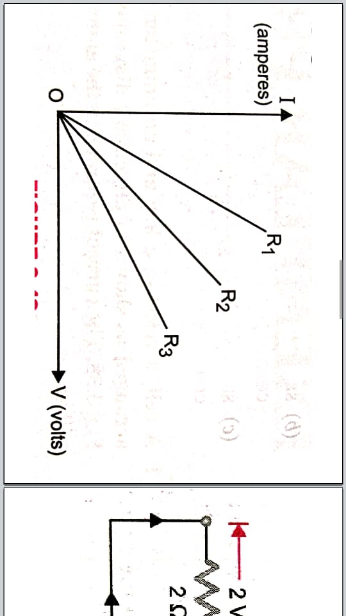

|  |  |  |  |
| --- | --- | --- | --- |
| a) R1 = R2 = R3 | b) R1 > R2 > R3 | c) R3 > R2 > R1 | d) R2 > R3 > R1 |

1. The resistivity does not change if :

|  |  |
| --- | --- |
| a) the material is changed | b) the temperature is changed |
| c) the shape of the resistor is changed | d) both material and temperature are changed |

1. An electric bulb marked 40 W – 200 V is used in a circuit of supply voltage 100 V. Its power now is :

|  |  |  |  |
| --- | --- | --- | --- |
| a) 100 W | b) 40 W | c) 20 W | d) 10 W |

1. The amount of charge that flows through a circuit carrying a circuit of 0.6 A for 2 h is ………………. [ 1 ]
2. Two resistances of 6 Ω each are connected in parallel. The equivalent resistance is …………… [ 1 ]
3. Define current. Give its SI unit. [ 1 ]
4. Define 1 volt. [ 1 ]
5. Calculate the current through a lamp of 25 W operating at 200 V. [ 1 ]
6. Which combination of resistors is used to decrease current in a circuit? [ 1 ]
7. A current of 0.5 A is drawn by a filament of an electric bulb for 10 minutes. Find the amount of electric charge that flows through any point of the circuit. [ 1 ]
8. Define ohm’s law and draw V-I graph. [ 2 ]
9. Write two factors on which resistance of a conductor depends. [ 2 ]
10. An electric bulb of resistance 400 Ω, draws a current of 0.5 A. Calculate the power of the bulb and the potential difference at its ends. [ 2 ]
11. A resistance of 40 Ω is bent in the form of a closed circle. What is the effective resistance between the two at the ends of any diameter of this circle [ 2 ]
12. Two identical resistors, each of resistor 2 Ω , are connected in turn : (i) in series (ii) in parallel to a battery of 12 V. Calculate the ratio of powers consumed in two cases. [ 2 ]
13. Calculate the effective resistances between the points A and B in the network shown in figure: [ 2 ]

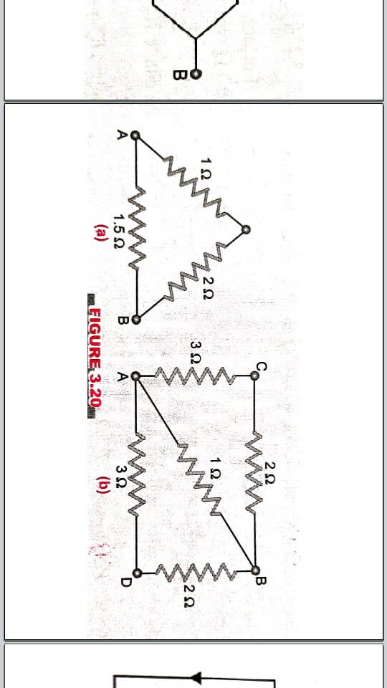

1. Calculate the cost of running the following electrical devices in the month of September if the rate of 1 unit of electricity is Rs. 6.00. [ 3 ]
2. Electric heater of 1000 W for 5 hours daily (ii) Electric refrigerator of 400 W for 10 hours daily